1. **COMPANY PROFILE**

**COMPANY PROFILE:-**

ALIVE TECH SERVICES A leading IT and business skills training provider with ITES registration. Training is provided by IT professionals who have more than 7 years of real time experience, so that the best quality output will be delivered. We foster career in technologies like Cloud computing Android Java .Net PHP SEO Web Design and software testing .Offering the most relevant and timely content delivered by the best instructors, we provide customers with their choice of convenient class times, delivery methods and formats to accelerate their success. We offer a wide array of solutions be spoken for a variety of key verticals and horizontals in the IT industry. **TECH**

**Clients:-**

* **HONDA SHOWROOMS.**
* **YAMAHA SHOWROOM.**
* **SHREE AUTOMOBILES.**

**Contact Details:**

**Address:**

### 17/1, Amar Plaza 1st floor

### IT Park, Parsodi

### Nagpur, 440022

### **Contact Info:** Tel: +91 0712-6061777

**2. PROJECT PROFILE**

**PROJECT PROFILE:-**

In this project the main objectives of the project on Vehicle Showroom Management System is to manage the details of employee salary and registration. It manages all the information about employee, skill, registration, and employee. The project is totally built at administrative end and thus only the administrator is guaranteed the access. The purpose of the project is to build an application program to reduce the manual work for the managing the employee, salary. It tracks all the details about the leaves, attendance, registration, Employee System is basic application build from the ASP.net MVC and Entity Framework. It has CRUD operation like Create, Edit, Delete and View Detail functionality. I have built the same application with static data in my previous post, now I am taking one step ahead to use the database to store our data.

**Module Description:-**

1. **Application :-**

In this module, we create application for employment form for getting employees data like personal details, Educations History, Employment History and skills etc.s

1. **Interview Schedule:-**

In this module, to maintain the interview schedule such as the id date time post all employees.

1. **Salary Management:-**

In this module, to maintain the all employee salary and records to calculate the monthly salary.

1. **Attendance: -**In this module, Employee Attendance Management is a complete tool for tracking employee attendance, working hours, holidays, and more. You can use it to create employee ID cards, attendance records, and more, as well as submitting and approving or denying requests for leave. This software allows you to track employee attendance at a glance.
2. **Feedback:-**

In this module, the performance feedback process is ongoing employees **the employee should never hear about positive performance or performance in need of improvement for the first time**at your formal performance discussion meeting unless it is new information or insight..

1. **Skill Management:-**

In this module, Top 5 Skills for Effective Employee Management. The essence of effective leadership is motivating your team to consistently perform while instilling a desire to improve, as well as cultivate employee loyalty to colleagues, yourself and, ideally, the company**.**

1. **Reports:-**

In this module, to create the report all Vehicle Showroom and employee properly display the progress

**3. INTRODUCTION**

* **PROBLEM DEFINITION:-**

The problem definition for designing the system is to maintain data of employee, to make easy controlling employees, to divide jobs and access control of employees, to use technology for accurate and timely processing by fully privacy and full authority access. The objective of the project is to set up employee information system about status of employee and attendance of employee and monthly salary process and delivery. To eliminate or reduce as much as possible the hardships of existing system and avoid errors while entering data. In existing method employee management are employee record are maintain in records. It’s a manual process. Complicated to search the employee salary.

* **PRESENT SYSTEM IN USE:-**

**Vehicle Showroom Management System is to reduce the manual operation required to maintain all the records of Employees. And also generates the various reports for analysis. The purpose of Vehicle Showroom Management is to perform monthly salary generation, Attendance, leave sanctions of the employees and to perform search regarding various categories within less time. It reduces the human effort by making everything computerized. Here we published Vehicle Showroom Management System**

•Knowledge databases -- While not necessarily seen as actual training, these databases are the most basic form of e-learning. You've probably seen knowledge databases on software sites offering indexed explanations and guidance for software questions, along with step-by-step instructions for performing specific tasks. These are usually moderately interactive, meaning that you can either type in a key word or phrase to search the database, or make a selection from an alphabetical list.

•Online support -- Online support is also a form of e-learning and functions in a similar manner to knowledge databases. Online support comes in the form of forums, chat rooms, online bulletin boards, e-mail, or live instant-messaging support. Slightly more interactive than knowledge databases, online support offers the opportunity for more specific questions and answers, as well as more immediate answers.

•Asynchronous training -- This is e-learning in the more traditional sense of the word. It involves self-paced learning, either CD-ROM-based, Network-based, Intranet-based or Internet-based. It may include access to instructors through online bulletin boards, online discussion groups and e-mail. Or, it may be totally self-contained with links to reference materials in place of a live instructor.

•Synchronous training -- Synchronous training is done in real-time with a live instructor facilitating the training. Everyone logs in at a set time and can communicate directly with the instructor and with each other. You can raise your cyber hand and even view the cyber whiteboard. It lasts for a set amount of time -- from a single session to several weeks, months or even years. This type of training usually takes place via Internet Web sites, audio- or video-conferencing, Internet telephony, or even two-way live broadcasts to students in a classroom.

* **FLAWS IN PRESENT SYSTEM:-**

Every system contains some flaws. **Vehicle Showroom Management is to reduce the manual operation required to maintain all the records of Employees. And also generates the various reports for analysis. The purpose of Vehicle Showroom Management is to perform monthly salary generation, Attendance, leave sanctions of the employees and to perform search regarding various categories within less time. It reduces the human effort by making everything computerized**.

**This Application works in Multiple PC’s installed on multiple Computers but sharing same database by which users of different department can use it sitting at different locations simultaneously. But in the future we can publish this application in web. Hence it works more Convenient.**

**The main reason for choosing this topic is to reduce the time and complexity of maintaining the records and also to easily perform the task of book keeping. It also helps in accurate maintenance of employee details and calculating their salary.**.Some participants need a long time to get a good grasp of understanding the systems and strict structures of the online classroom. Many stray files placed outside the correct virtual group rooms (folders) make it difficult to navigate and finding the correct ongoing discussion. Some participants spend so much time searching for the right place that they give up their study because they get lost in a jungle of stray files on a slow internet connection.

The student is supposed to become an independent and self-reliant learner, but shall also rely on others to learn  
Constructivist pedagogy strives to develop reflection and the skill of learning how to learn. The goal of facilitating learning is to support the development of independent learning, and eventually guide the learners to teach themselves. In addition, socio-constructivist pedagogy emphasises learning by collaborative activities in a relevant context. “Positive interdependence is the knowledge that you are linked closely with others in the learning task and that success (personal and for the group) depends on each person working together to complete the task”

**Assessments. The end of grade test**  
How can we ensure that we test what we value?  The traditional test is summative.  A summative test tends to assess how good you are at taking a test, not necessarily how much you actually have learned. Ideally, knowledge and skills should be demonstrated through practical performance, not through a standardized test with multiple choice questions.  Students tend to focus on how to pass the end of grade test, and less on learning.  How do we make assessments an effective part of learning activities? We know that the formative kind of tests give more room for learning than the summative tests. Formative tests give feedback on how to improve. In other words, formative tests involve constructive criticism, summative just criticism. Some have compared formative tests to regular medical examinations with a check of status and good advice on how to do better. A summative test is comparable to the autopsy. So why do we do all this summative testing? There are other ways of assessing knowledge and skills than just school exams. A standardised test asks all to do the same test, no matter of personal interests and skills. Future learning should perhaps individualise more. Should we for example consider using[**badges**](http://www.learningtimes.com/what-we-do/badges/) in learning more frequently? [Badges](http://en.wikipedia.org/wiki/Digital_badges) indicate skills or accomplishments earned in different kinds of learning environments. Many know this kind of assessment system from boys and girls scouts and the military. But this type of assessment requires a more flexible approach to education than we are used to today.

The online discussions are intended to rationalise production of concrete results, and thus connected to and act as a basis for the writing of articles and hand-ins, whether this is done by the group or individually. Students who participate actively in the discussions find that their understanding of the issue, their ability to form critical standpoints and their ability to express opinions instead of just repeating a source will be considerably strengthened.

* **NEED FOR NEW SYSTEM :-**

There are some disadvantages for the existing system. Hence we can build the new system i.e. Vehicle Showroom management system. In new System we provide friendly environment to the teacher and students. In Vehicle Showroom management system we provide educational material for study for student as well as teachers .There is some need for that System.

* The proposed system is intranet based system so employee can also participate in this system and track their status.
* The Proposed system provides domain login as per organization requirement so no need to remember user id or password.
* The proposed system provides detail general information about the employee along with Educational, Certification, Skill and Project details.
* It enhances the HR Management in adding, viewing and updating employees’ details and generates various reports regarding employee’s skill and experience.
* The proposed system of HR Module is the right software to be incorporated into the

Automation of HR Software for helping the organization needs with respect to skillful

Human Resource.

* **PROPOSED SYSTEM:-**

This Employee attendance management system is used for keeping the record of an employee in an organized organization such as school, college, universities, etc. Our project aims designing an employee attendance system which could effectively manage attendance of employee at institutes, organisation, etc. This application maintains a database which has the details of the employees such as their name, unique id, image, designation, date of joining etc. this application must be placed in the head office of any organisation. Employees instead of signing in the attendance Register, they can simply use this mobile application and enter their unique id. Once ID is given, the front camera of the android mobile phone captures the image of the employee. The captured image is compared with the image in the database for a valid user and attendance is updated automatically. The generated report will be automatically mailed once the time limit exceeds. This image comparison helps in avoiding proxy attendance by other.

**Advantages:**

* Help in maintaining the computerized employee details.
* Calculate the salary, Easy attendance marking.
* More Efficient and reliable Less time consuming and easy to use Avoid human error and effort for maintaining daily data.
* Huge data storage with less computer memory.

The proposed system is designed to eliminate all the drawbacks of the existing system. The system is part of a large HRMS Application and shall be responsible for maintaining information about employees,

* + - * positions,
      * company benefits,
      * departments,
      * new recruit checklists,
      * employee achievements,
      * administration,
      * Work changes and several ad hoc reports.

The major advantage of the proposed system is,

* + - * It’s online, so that information is available any time.
      * High integrity and security.
      * Ability to incorporate newly available data.
      * It is user friendly
      * Speed and accuracy is increased
      * Fully automated.
      * Security is associated with user authentication

**4. ANALYSES**

* **FEASIBILITY STUDY:**

Feasibility study is the study of the system to check whether the system made is feasible or not. It is very Useful to check whether the system work as per the requirement or not. It is undertaken to determine the possibility of the probability of developing completely new system.

**-: Need of the feasibility study :-**

* Answer the question whether the new system is to be developed or Not?
* Define the problem and objectives involved.
* Is the cost incurred in the development of the system of the Justified?

**-: Operational feasibility:-**

It covers mainly two aspects. It determines that how the proposed system will fit in the current operation and what if the job retraining and restructuring may be needed at the end of the implementation of the system. The operational feasibility checks whether user who is going to use the system as able to work with the software with which the system is coded!

In the system Operation feasibility following are the question to be asked!

* Is there sufficient support for the system?
* Is current method are acceptable to the user?
* Have the user been involved in the planning and development of the system?
* System is very useful for online system.
* System is very user-friendly.
* Level of security and any other access control constrains are high.

**-: Technical feasibility:-**

It determines that work for the system is done with the present equipment’s and existing software technology.

Necessary all things is easily feasible for the system. Necessary technology, documents, reports are also available. Technical guarantee of accuracy, reliability and security are also provided.

It asks following question?

* Does necessary technology exists to do what is suggested?
* Do the Proposed equipment’s have the technical capacity to hold the data required to use new system?
* Are there technical guarantees of accuracy, reliability ease of access and data security?

**-: Economical feasibility:-**

It looks the financial aspects of the system. Economic feasibility concerns with the returns of the investments in the system. It determines whether it is worthwhile to invest money in the proposed system?

It asks for the following question.

* What is the cost to conduct a full system investigation?
* What is the cost of hardware and software required in the development of the proposed system?
* Estimated cost is fitted in budget. (I.e. cost of software and hardware is feasible to common person.)s
* **REQUIRED ANALYSIS:-**
* **Software tools used:**

**Software: -**.NET Framework (pronounced *dot net*) is a software framework developed by Microsoft that runs primarily on Microsoft Windows. It includes a large class library named Framework Class Library (FCL) and provides language interoperability (each language can use code written in other languages) across several programming languages. Programs written for .NET Framework execute in a software environment (in contrast to a hardware environment) named Common Language Runtime(CLR), an application virtual machine that provides services such as security, memory management, and exception handling. (As such, computer code written using .NET Framework is called "managed code".) FCL and CLR together constitute .NET Framework.FCL provides user interface, data access, database connectivity, cryptography, web application development, numeric algorithms, and network communications. Programmers produce software by combining their source code with .NET Framework and other libraries. The framework is intended to be used by most new applications created for the Windows platform. Microsoft also produces an integrated development environment largely for .NET software called Visual Studio.s

For running this project efficiently, following is a minimum software required specification

1. Operating System : Windows10

2. Language : ASP.NET (MVC)

3. Database : SQL Server 2008

4. Web Browser : Google Chrome

**Tools:-**

**Visual Studio 2017: -**The key development tool for building ASP.NET applications and front ends is Visual Studio. In this tutorial, we work with Visual Studio 2017.

Visual Studio is an integrated development environment for writing, compiling, and debugging the code. It provides a complete set of development tools for building ASP.NET web applications, web services, desktop applications, and mobile applications

**Languages to be used:-**

**ASP.NET:-** ASP.NET is a web development platform, which provides a programming model, a comprehensive software infrastructure and various services required to build up robust web applications for PC as well as mobile devices.

ASP.NET works on top of the HTTP protocol, and uses the HTTP commands and policies to set a browser-to-server bilateral communication and cooperation.

ASP.NET is a part of Microsoft .Net platform. ASP.NET applications are compiled codes, written using the extensible and reusable components or objects present in .Net framework. These codes can use the entire hierarchy of classes in .Net framework.

**Framework:-**

**MVC (Entity Framework):-** Entity Framework was first released in 2008, Microsoft's primary means of interacting between .NET applications and relational databases. Entity Framework is an Object Relational Mapper (ORM) which is a type of tool that simplifies mapping between objects in your software to the tables and columns of a relational database.

Entity Framework (EF) is an open source ORM framework for ADO.NET which is a part of .NET Framework.

An ORM takes care of creating database connections and executing commands, as well as taking query results and automatically materializing those results as your application objects.

An ORM also helps to keep track of changes to those objects, and when instructed, it will also persist those changes back to the database for you.

**Designing:-**

**SWING :-** SWING is used to design Vehicle Showroom Management System UI .HTML5 is a markup language used for structuring and presenting content on the desktop.

HTML5 includes detailed processing models to encourage more interoperable implementations; it extends, improves and rationalizes the markup available for documents, and introduces markup and application programming interfaces (APIs) for complex web applications. For the same reasons, HTML5 is also a candidate for cross-platform mobile applications, because it includes features designed with low-powered devices such as smartphones and tablets.

**CSS3: -** CSS3 is used for apply the style on Vehicle Showroom Management System web page. Cascading Style Sheets (CSS) is a style sheet language used for describing the presentation of a document written in a markup language.[1] Although most often used to set the visual style of web pages and user interfaces written in HTML and XHTML, the language can be applied to any XML document, including plain XML, SVG and XUL, and is applicable to rendering in speech, or on other media. Along with HTML and JavaScript, CSS is a cornerstone technology used by most websites to create visually engaging webpages, user interfaces for web applications, and user interfaces for many mobile applications.

**Bootstrap: -**Bootstrap is the most popular HTML, CSS, and JavaScript framework for developing responsive, mobile-first web sites.

Bootstrap is a free and open-source front-end web framework for designing websites and web applications. It contains HTML- and CSS-based design templates for typography, forms, buttons, navigation and other interface components, as well as optional JavaScript extensions. Unlike many web frameworks, it concerns itself with front-end development only.

**JQurey: -** jQuery is a cross-platform JavaScript library designed to simplify the client-side scripting of HTML. jQuery is the most popular JavaScript library in use today. jQuery's syntax is designed to make it easier to navigate a document, select DOM elements, create animations, handle events, and develop Ajax applications. jQuery also provides capabilities for developers to create plug-ins on top of the JavaScript library. This enables developers to create abstractions for low-level interaction and animation, advanced effects and high-level, theme-able widgets.

**Database:-**

**SQL Server: -** SQL Server is software (A Relational Database Management System) developed by Microsoft. It is also called MS SQL Server. It is implemented from the specification of RDBMS.

Our SQL Server Tutorial includes all topics of SQL Server such as SQL Server tutorial with SQL Server, install visual studio, install SQL Server, architecture, management studio, data types, dB operations, login database, create database, select database, drop database, create table, delete table, update table, min function, max function, sum function, sql operators, advance operator, clauses, create view, keys constraints and indexes, primary keys, foreign keys, indexes etc.

* **CFD (CONTEXT FLOW DIAGRAM):-**

**Employee**

**ADMIN**

**Login for Update**

**Replay**

**Login**

**employee Info**.

5. **DESIGN**

* **SYSTEM FLOW DIAGRAM:-**

**Start**

**Username/Password**

**Login**

**Authentication**

**Admin**

**Add/Delete**

**Update**

**Logout**

**End**

**Resources**

**No**

**Yes**

**Yes**

* **DATA DICTIONARY:-**

Table Application Form

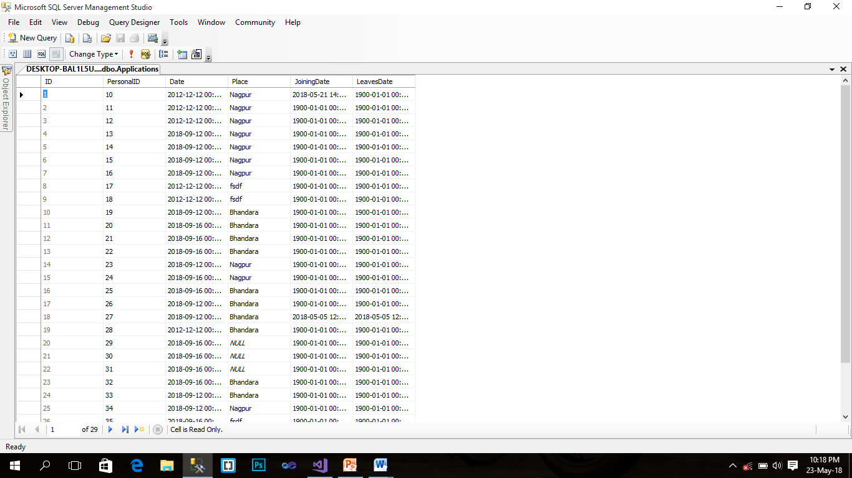

Table Attendance

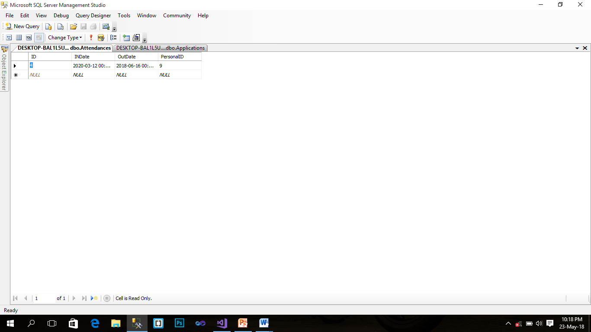

Table Education

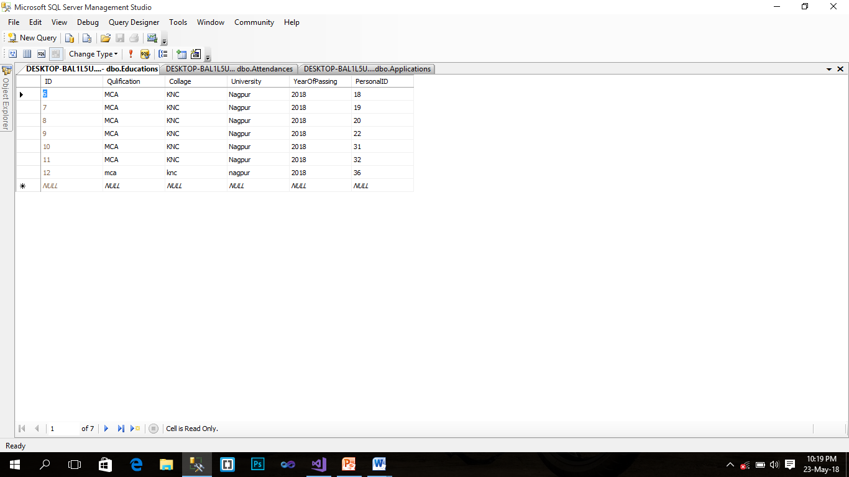



Table Feedback

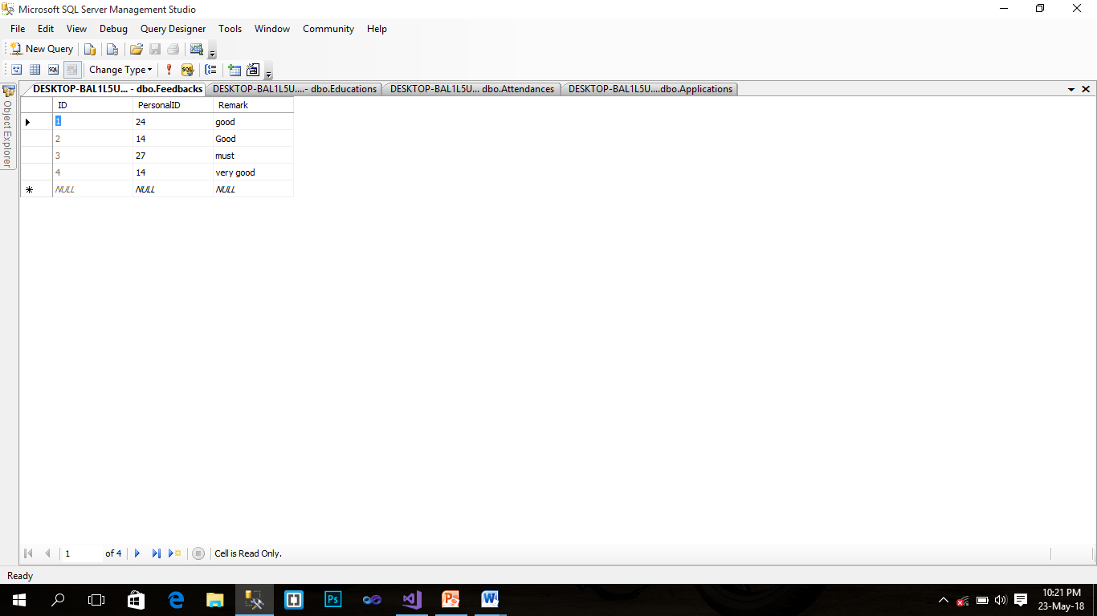

* **DATA FLOW DIAGRAMS:-**

**0 Levels:**

Login

Admin

Vehicle Showroom Management System

Database

**1st LEVEL DFD FOR**

**ADMIN**

Admin

Reply

Login

Login Master

Login info.

Login Details

Employee

Reply

Submit for Reg.

Employee Master

Employee info.

Reply

Update his profile

Update information

Repot

CommunicateDetails

**2nd level DFD**

Employee

Uid & pwd

In valid

Login master

Uid & pwd

Post master

* **DECISION TABLES/ TREES:-**

Authenticate

Monitoring

Organize task

Create Application

View

Vehicle Showroom management system

Login

Admin

Report

Create Application

View

Report

**s**

**6. SCREEN / REPORTS**

## **1 I/O SCREENS:-**

Home Page

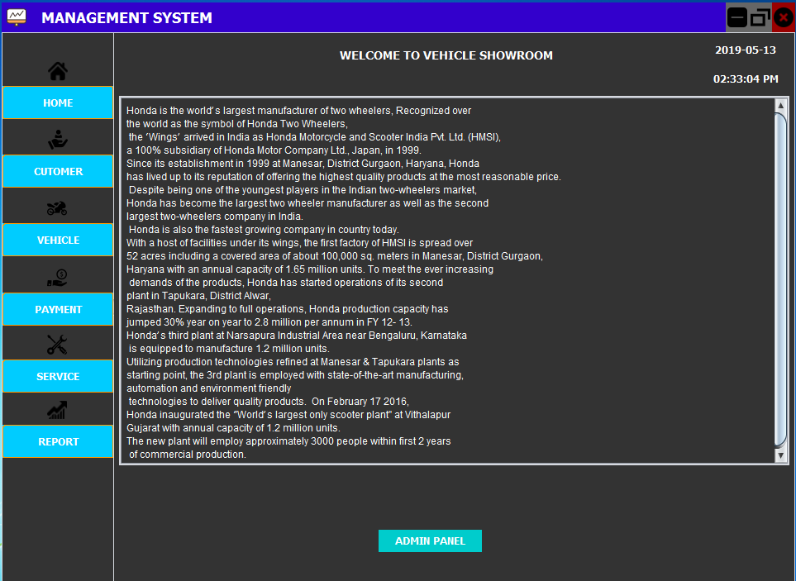

Login Page

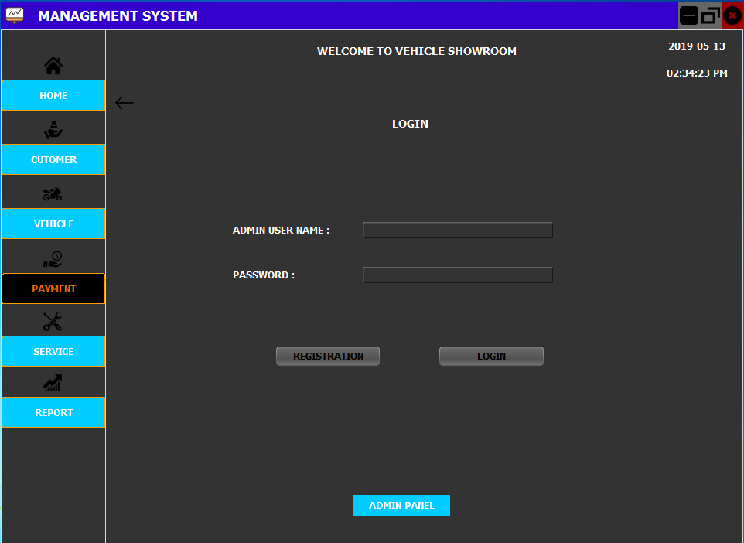

Register Page

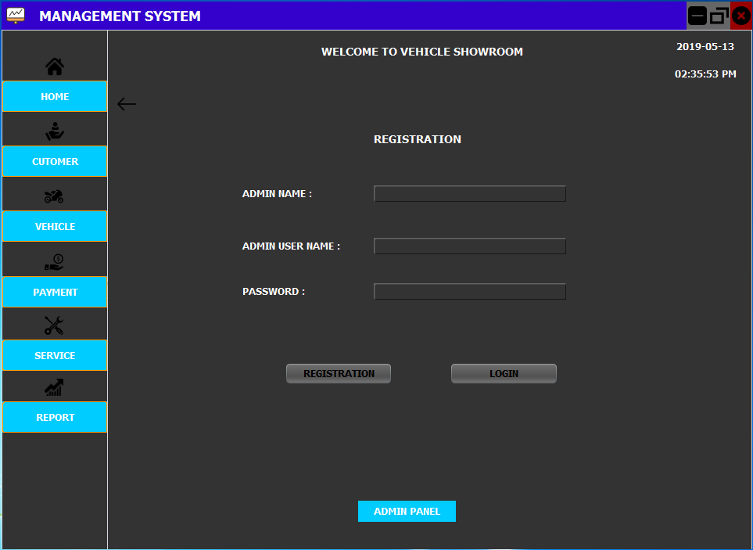

Application form

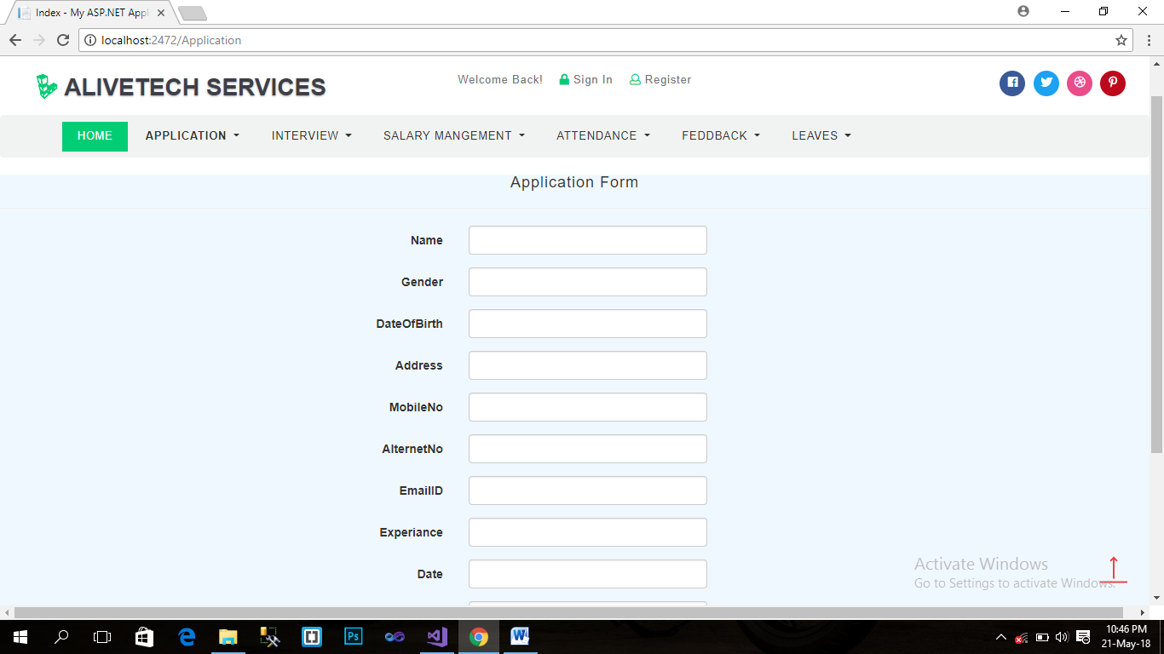

Interview:-

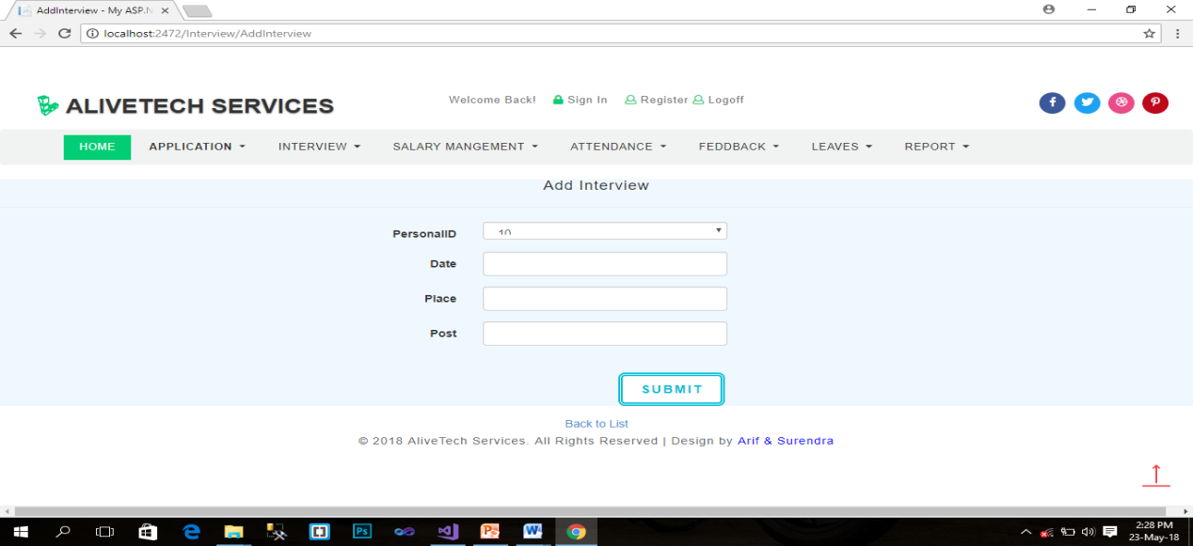

Salary Management:-

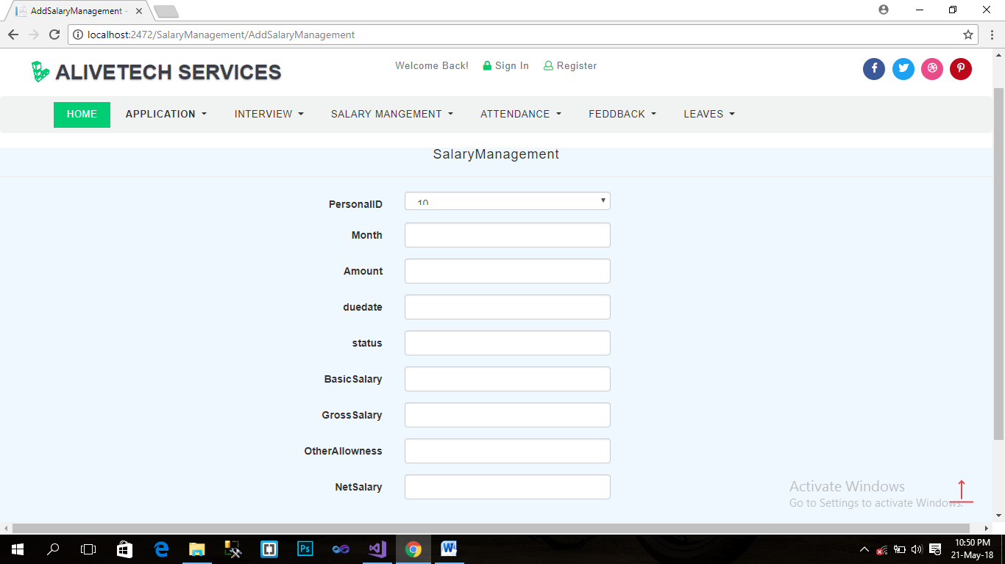

Attendance:-

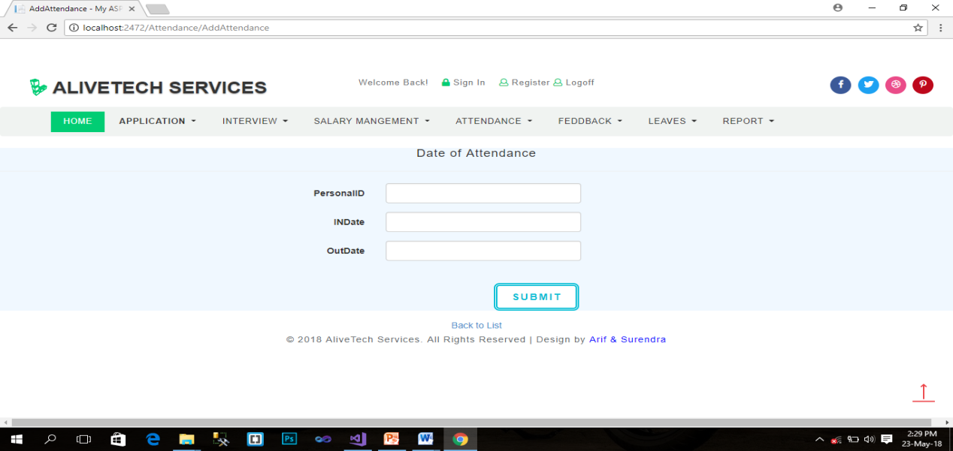

Feedback:-

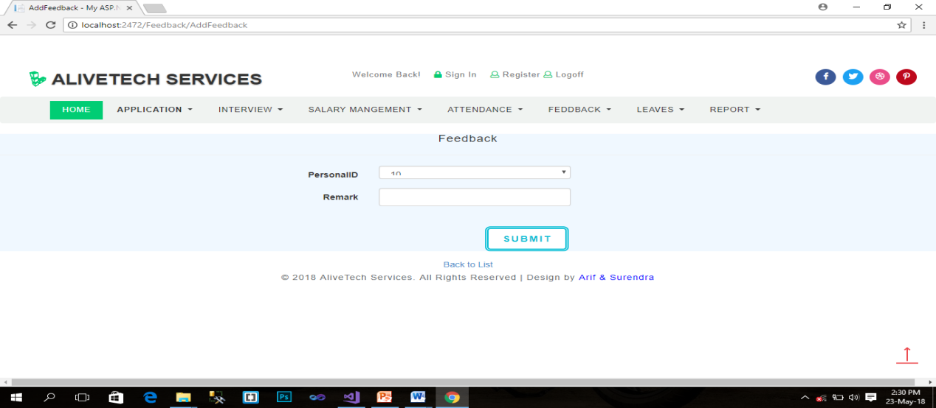

Levees:-

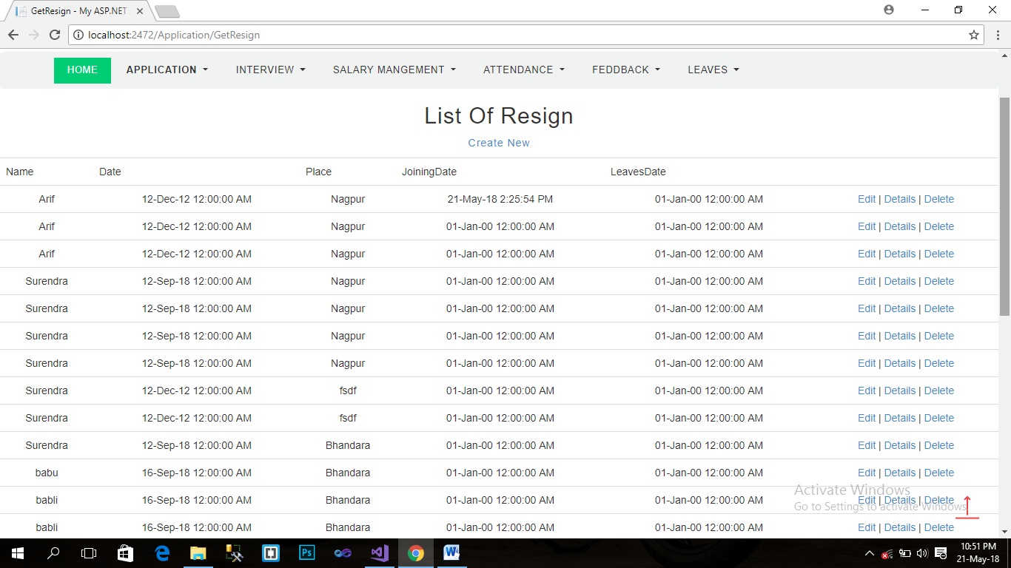

Report:-

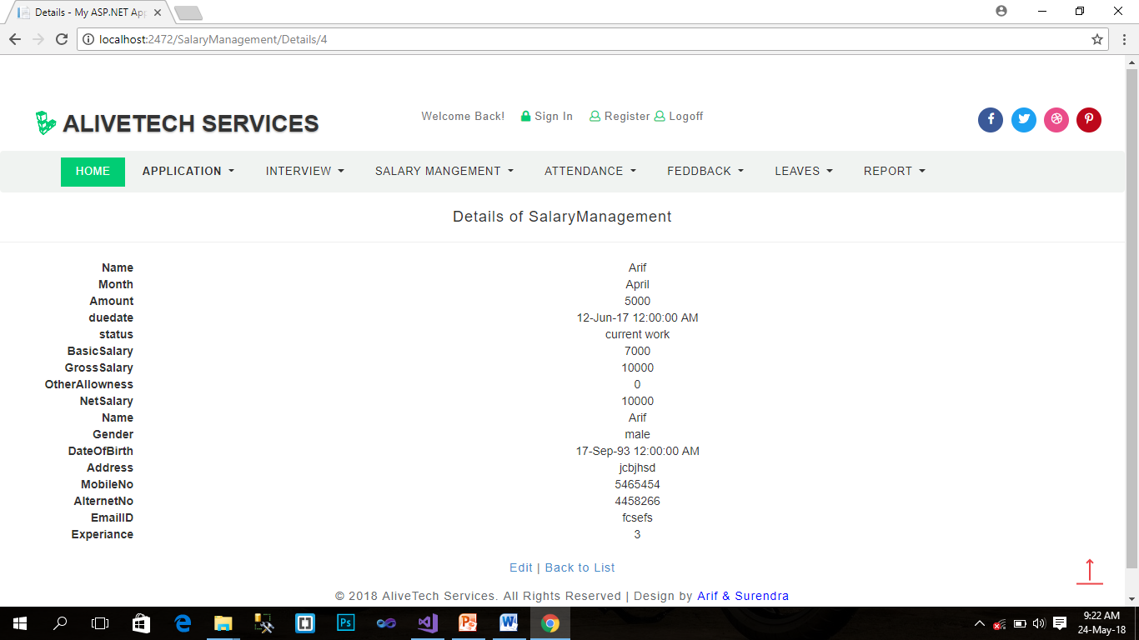

**7**. **TESTING**

**TESTING:-**

This phase determine the error in the project. If there is any error then it must be removed before delivery of the project. For determining errors various types of test action are performed.

1. **Unit Testing: -**

Unit testing focuses verification effort on the smallest unit of software design – the module. Using the detail design description as a guide, important control paths are tested to uncover errors within the boundary of the module. The relative complexity of tests and the errors detected as a result is limited by the constrained scope established for unit testing. The unit test is always white box oriented, and the step can be conducted in parallel for multiple modules.

Unit testing is normally considered an adjunct to the coding step. After source level code has been developed, reviewed, and verified for correct syntax, unit test case design begins. A review of design information provides guidance for establishing test cases that are likely to uncover errors. Each test case should be coupled with a asset of expected results.

Because a module is not a stand-alone program, driver and/or stub software must be developed for each unit test. In most applications a driver is nothing more than a main program that accepts test case data passes such data to the module(to be tested),and prints the relevant results. Stubs serve to replace modules that are subordinate (called by) the module to be tested. Stub or “dummy subprogram” users the subordinate module’s interface, may do minimal data manipulation, prints verification of entry and returns.

Drivers and stubs represent overhead. That is, both are software that must be written but tat is not delivered with the final software product. If drivers and stubs are kept simple, actual overhead is relatively low. Unfortunately, many modules cannot be adequately unit tested with “simple” overhead software. In such cases, complete testing can be postponed until the integration test step.

Unit testing is simplified when a module with high cohesion is designed. When only one function is addressed by a module, the number of test cases is reduced and errors can be more easily predicted and uncovered.

1. **System Testing: -**

Software is only one element of a larger computer based system. Ultimately, software is incorporated with other system elements (e.g. new hardware, information), and a series of system integration and validation tests are conducted. Steps taken during software design and testing can greatly improve the probability of successful software integration in the larger system.

A classics system testing problem is “finger pointing”. This occurs when a defect is uncovered, and one system element developer blames another for the problem. Rather that including in such nonsense, the software engineer should anticipate potential interfacing problems and (1) design error handling paths that test all information coming from other elements of the system.(2) conduct a series of tests that simulate bad data or other potential errors at the software interface; (3) record the results or tests to use as “evidence” if finger pointing does occur (4) participate in the planning and design of system test to ensure that software is adequately tested.

There are many types of system tests, which are worthwhile for software-based systems, as detailed hereunder:

Recovery testing is a system test that forces the software to fail in a variety of ways that verifies that recovery is properly performed.

Security testing attempts to verify that protection mechanisms built into a system will protect it from improper penetration

Stress tests are designed to confront programs with abnormal situations.

Performance testing is designed to test the run-time performance of software within the context of an integrated system.

1. **Integration Testing: -**

A neophyte in the software world might ask a seemingly legitimate question once all modules have been unit-tested. If they all work individually, why do you doubt that they’ll work when we put tem together? The problem, of course, is putting them together – interfacing. Date can be lost across an interface; one module can have an inadvertent, adverse effect on anther, sub functions, when combined, may not produce the desired major function; individually acceptable imprecision may be magnified to unacceptable levels; global data structures can present problems. Sadly, the list goes on and on.

Integration testing is a systematic technique for construction the program structure while at the same time conduction test to uncover errors associated with interfacing. The objective is to take unit tested modules and build a program structure that has been dictated by design. There is often a tendency to attempt non-incremental integration; that is, to construct the program using a big bang approach. All modules are combined in advance. The entire program is tested as a whole. And chaos usually results! A set of errors are encountered. Correction is difficult because the isolation of causes is complicated by the vast expanse of the entire program. Once these errors are corrected, new ones appear and the process continues in a seemingly endless loop.

Incremental integration is the antithesis of the “big bang” approach. The program is constructed and tested is small segments, where errors are easier to isolate and correct; interfaces are more likely to be tested completely, and a systematic test approach may be applied.

Integration testing can be categorized into two types, namely top-down integration or bottom-up integration. Top-down integration is an incremental approach to the construction of program structure. Modules are integrated by moving downward through the control hierarchy, beginning with the main control module. Modules subordinate to the main control module are incorporated into the structure in either a depth-first or breadth-first manner. The bottom-up integration testing as its name implies, begins construction and testing with atomic modules. Because modules are integrated for the bottom up processing required for modules subordinate to given level is always available and the need for stubs is eliminated.

The selection of an integration strategy depends upon software characteristic and, sometime project schedule. In general, a combined approach that uses the top-down strategy for the upper levels of the program structure, coupled with a bottom-up strategy for the subordinate levels, may be the best compromise.

**8. IMPLEMENTATION**

### **IMPLEMENTATION:-**

**Pre-Implementation Assessment Overview:**

Implementation of mission critical software will introduce risk to an organization. The degree of risk rises with increases in scope of affected operations and complexity of the software. Avoidable project risk is first introduced when there is lack of planning and Preparation prior to actually starting the implementation.

Proactive discovery and Mitigation of risk will reduce the severity of issues during and after the implementation Project. Risks discovered after the implementation is underway are usually addressed in a less than optimal manner to avoid project delays and cost overruns.

Inadequate planning and risk management will likely result in less than satisfactory organizational performance following the implementation due to:

* Inadequate user training, and
* Inadequate reports needed to monitor performance.

Risk is minimized when a thorough assessment is conducted prior to beginning the implementation. The goal is to proactively identify possible sources of risk, workable Solutions to mitigate the risk, and contingency plans for risks that cannot be thoroughly assessed. Avoiding significant issue discovery and redirection during the course of the Project will diminish the overall degree of difficulty.

# Post-Implementation Reviews:

"Completing a project" is not the same thing as ending the project management process. Simply finishing doesn't ensure that the organization benefits from the project's outcome.

For example, after completing a year long project to establish a new quality management process for your organization, you want to make sure that what you set out to do was actually achieved. Your objective wasn't to simply deliver a process - but rather, to deliver the process that addresses the specific business need you intended to meet. This is the real measure of success.

You also need to ensure that the lessons learned during the project are not forgotten. You can more effectively design and execute future projects when you take advantage of lessons learned through experience of previous projects.

So how can you properly measure a project's success, and work toward continuous improvement? This is where the process of Post-Implementation Review (PIR) is helpful. It helps you answer the following key questions:

* Did the project fully solve the problem that it was designed to address?
* Can we take things further, and deliver even bigger benefits?
* What lessons did we learn that we can apply to future projects?

**Implementation of this project requires following steps:**

1. Install operating system in the machine.

2. Install Browser open project.

**9. CONCLUSION**

#### **CONCLUSION:-**

* Vehicle Showroom Management is to reduce the manual operation required to maintain all the records of Employees. And also generates the various reports for analysis. The purpose of Vehicle Showroom Management is to perform monthly salary generation, Attendance, leave sanctions of the employees and to perform search regarding various categories within less time. It reduces the human effort by making everything computerized.

**10. LIMITATIONS**

**LIMITATIONS:-**

* Network Connection.
* No online payment.

**11. BIBLIOGRAPHY/ REFRENCES**

**BIBLIOGRAPHY/ REFRENCES:-**

1. System analysis and design by Elias M.Awad
2. Software Engineering by A Bractitioner’s Apprach,Rojer S Pressman,MacGraw-hill
3. Websites:-

* [www.w3schools.com](http://www.w3schools.com)
* www.microsoft.com
* www.google.com

1. Complete reference ASP.NET by Matthew MacDonald-Tata McGraw-Hill.